SIMATS ENGINEERING
ASSESSMENT TOOL 1 - Concept Mapping

COURSE NAME: Data Structures COURSE CODE: CSA03
Register Number | 1925260079
Name | C.Nikitha

COURSE OUTCOME COVERED

CO1: Apply suitable data structures and ADTs for efficient problem solving by analyzing time and space complexity. (BL2, BL3)

Assessment Tool Weightage: 35%

Questions:2 | EACH QUESTIONS CARRIES: 10 MARKS Total Marks:20 Duration: ONE HOUR
Q1 A smart healthcare system processes large volumes of patient data such as temperature readings, medical history, and diagnostic details. Construct a concept map linking the progression from Data → Data Object → Data Structure → Abstract Data Type (ADT) → Implementation in C. Identify relevant sub-concepts such as structures, pointers, and operations, and establish meaningful relationships among them. Organize the concept map hierarchically and justify how each level contributes to efficient data organization, processing, and improved system performance.
Q2 A smart city traffic management system handles data related to vehicle movement, road networks,
and signal control. Construct a concept map connecting Primitive Data Structures → Non-Primitive Data Structures → Linear → Non-Linear Structures. Include examples such as arrays, linked lists, trees, and graphs, and illustrate their applications in traffic management. Explain the relationships between these structures and justify their classification based on functionality and efficiency.

Code of Conduct:

I C.NIKITHJA(1925260079) (Name / Reg No) certify that this submission is my original work and that I have adhered to the guidelines specified for this assessment.
I understand that any violation of academic integrity rules will result in disciplinary actionSignature Signature of the student:


RUBRICS FOR CALCULATION:

Concept Mapping
Criteria | Weightage | Level 4 (Exemplary) | Level 3 (Proficient) | Level 2 (Developing) | Level 1 (Beginning)
Concept Identification | 25% | Identifies all key concepts from literature accurately and comprehensively | Identifies most key concepts with minor omissions | Identifies limited concepts; some are irrelevant or missing | Fails to identify essential concepts
Linkages | 25% | Establishes clear, meaningful, and accurate relationships between concepts | Shows correct relationships with minor gaps | Relationships are weak, unclear, or partially incorrect | No meaningful relationships established
Organization | 20% | Concepts are well-structured hierarchically with logical flow and grouping | Mostly organized with minor structural issues | Some organization but lacks clear hierarchy | No logical organization or structure
Integration of Literature | 20% | Integrates multiple studies effectively to show connections and comparisons | Shows some integration of literature | Limited integration; mostly isolated concepts | No integration of literature evidence
Clarity | 10% | Concept map is clear, neat, visually structured, and easy to interpret | Generally clear with minor readability issues | Clarity is reduced; difficult to interpret in parts | Poorly presented and hard to understand

Answers:
1)
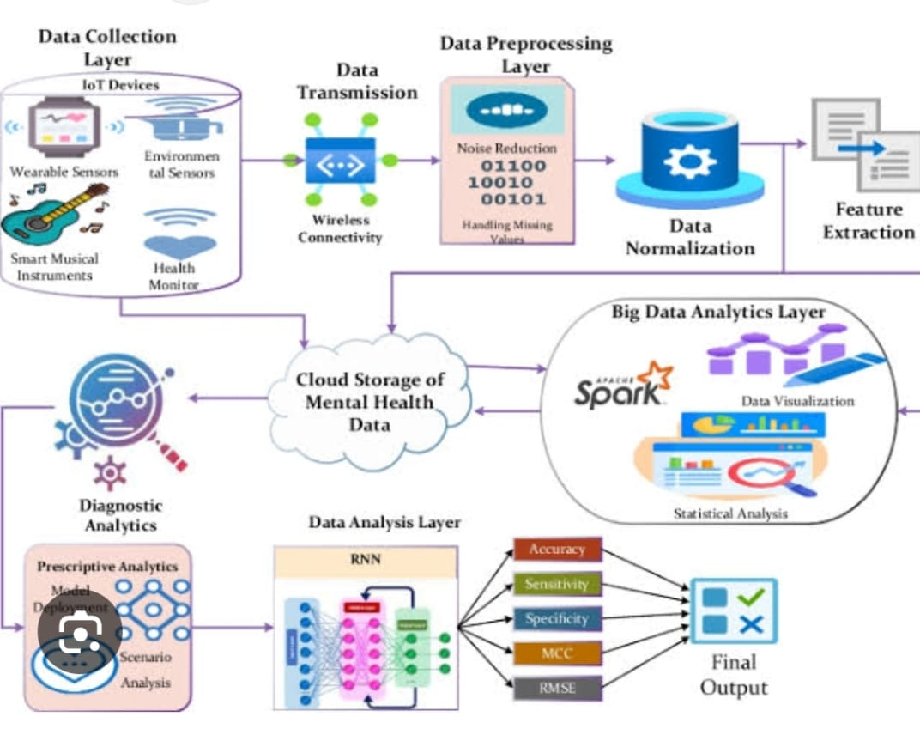
Mental Health Data Analysis Using IoT and Big Data
The diagram shows a system for collecting, processing, analyzing, and predicting mental health data using IoT, Cloud Computing, Big Data Analytics, and Machine Learning.
1. Data Collection Layer
Data is collected from IoT devices.
Examples include wearable sensors, environmental sensors, smart musical instruments, and health monitors.
These devices continuously collect information related to a person's health and environment.
2. Data Transmission
The collected data is transmitted through wireless connectivity.
The data is sent to the cloud/server for further processing.
3. Data Preprocessing Layer
Raw data may contain noise, errors, or missing values.
Noise reduction and missing-value handling are performed.
Data normalization converts the data into a suitable format for analysis.
4. Feature Extraction
Important information or features are extracted from the processed data.
These features help the system identify useful patterns related to mental health.
5. Cloud Storage
The collected and processed mental health data is stored in cloud storage.
Cloud storage allows large amounts of data to be stored and accessed easily.
6. Big Data Analytics Layer
Large amounts of mental health data are analyzed using tools such as Apache Spark.
Statistical analysis and data visualization are used to understand patterns and trends.
7. Data Analysis Layer
Machine learning/deep learning models such as RNN (Recurrent Neural Network) can analyze the data.
RNN is useful for analyzing time-based or sequential health data.
8. Diagnostic and Prescriptive Analytics
Diagnostic analytics helps understand possible causes or patterns in the data.
Prescriptive analytics can suggest suitable actions based on the analysis.
Scenario analysis and model deployment help in practical decision-making.
9. Performance Evaluation
The model is evaluated using:
Accuracy – how correctly the model predicts.
Sensitivity – ability to correctly identify positive cases.
Specificity – ability to correctly identify negative cases.
MCC – measures the quality of classification.
RMSE – measures prediction error.
10. Final Output
After analysis and evaluation, the system produces the final mental-health prediction/diagnostic output.
This can support healthcare professionals in monitoring and decision-making. Mental Health Data Analysis Using IoT and Big Data
The diagram shows a system for collecting, processing, analyzing, and predicting mental health data using IoT, Cloud Computing, Big Data Analytics, and Machine Learning.
1. Data Collection Layer
Data is collected from IoT devices.
Examples include wearable sensors, environmental sensors, smart musical instruments, and health monitors.
These devices continuously collect information related to a person's health and environment.
2. Data Transmission
The collected data is transmitted through wireless connectivity.
The data is sent to the cloud/server for further processing.
3. Data Preprocessing Layer
Raw data may contain noise, errors, or missing values.
Noise reduction and missing-value handling are performed.
Data normalization converts the data into a suitable format for analysis.
4. Feature Extraction
Important information or features are extracted from the processed data.
These features help the system identify useful patterns related to mental health.
5. Cloud Storage
The collected and processed mental health data is stored in cloud storage.
Cloud storage allows large amounts of data to be stored and accessed easily.
6. Big Data Analytics Layer
Large amounts of mental health data are analyzed using tools such as Apache Spark.
Statistical analysis and data visualization are used to understand patterns and trends.
7. Data Analysis Layer
Machine learning/deep learning models such as RNN (Recurrent Neural Network) can analyze the data.
RNN is useful for analyzing time-based or sequential health data.
8. Diagnostic and Prescriptive Analytics
Diagnostic analytics helps understand possible causes or patterns in the data.
Prescriptive analytics can suggest suitable actions based on the analysis.
Scenario analysis and model deployment help in practical decision-making.
9. Performance Evaluation
The model is evaluated using:
Accuracy – how correctly the model predicts.
Sensitivity – ability to correctly identify positive cases.
Specificity – ability to correctly identify negative cases.
MCC – measures the quality of classification.
RMSE – measures prediction error.
10. Final Output
After analysis and evaluation, the system produces the final mental-health prediction/diagnostic output.
This can support healthcare professionals in monitoring and decision-making.

2Q)

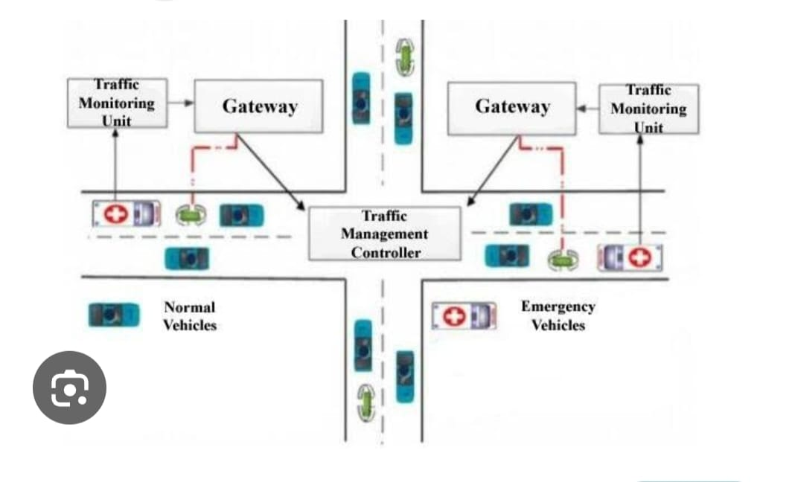
Traffic Management System – Explanation
The above picture shows an Intelligent Traffic Management System that gives priority to emergency vehicles such as ambulances.
Main Components
Traffic Monitoring Unit
Monitors the vehicles and traffic conditions on the road.
Detects emergency vehicles and sends information to the gateway.
Gateway
Receives information from the Traffic Monitoring Unit.
Transfers the information to the Traffic Management Controller.
Traffic Management Controller
Acts as the main controlling unit.
Analyzes the traffic information.
Gives priority to emergency vehicles and helps them move quickly.
Normal Vehicles
These are regular vehicles such as cars.
Their movement can be controlled when an emergency vehicle is approaching.
Emergency Vehicles
Ambulances and other emergency vehicles are given higher priority.
The system can create a clear path for them by controlling traffic.
Working
Traffic Monitoring Unit → Gateway → Traffic Management Controller → Traffic Control
When an ambulance approaches an intersection, the monitoring unit detects it. The information is sent through the gateway to the traffic management controller. The controller manages the traffic so that the emergency vehicle can pass quickly and safely. Traffic Management System – Explanation
The above picture shows an Intelligent Traffic Management System that gives priority to emergency vehicles such as ambulances.
Main Components
Traffic Monitoring Unit
Monitors the vehicles and traffic conditions on the road.
Detects emergency vehicles and sends information to the gateway.
Gateway
Receives information from the Traffic Monitoring Unit.
Transfers the information to the Traffic Management Controller.
Traffic Management Controller
Acts as the main controlling unit.
Analyzes the traffic information.
Gives priority to emergency vehicles and helps them move quickly.
Normal Vehicles
These are regular vehicles such as cars.
Their movement can be controlled when an emergency vehicle is approaching.
Emergency Vehicles
Ambulances and other emergency vehicles are given higher priority.
The system can create a clear path for them by controlling traffic.
Working
Traffic Monitoring Unit → Gateway → Traffic Management Controller → Traffic Control
When an ambulance approaches an intersection, the monitoring unit detects it. The information is sent through the gateway to the traffic management controller. The controller manages the traffic so that the emergency vehicle can pass quickly and safely. Traffic Management System – Explanation
The above picture shows an Intelligent Traffic Management System that gives priority to emergency vehicles such as ambulances.
Main Components
Traffic Monitoring Unit
Monitors the vehicles and traffic conditions on the road.
Detects emergency vehicles and sends information to the gateway.
Gateway
Receives information from the Traffic Monitoring Unit.
Transfers the information to the Traffic Management Controller.
Traffic Management Controller
Acts as the main controlling unit.
Analyzes the traffic information.
Gives priority to emergency vehicles and helps them move quickly.
Normal Vehicles
These are regular vehicles such as cars.
Their movement can be controlled when an emergency vehicle is approaching.
Emergency Vehicles
Ambulances and other emergency vehicles are given higher priority.
The system can create a clear path for them by controlling traffic.
Working
Traffic Monitoring Unit → Gateway → Traffic Management Controller → Traffic Control
When an ambulance approaches an intersection, the monitoring unit detects it. The information is sent through the gateway to the traffic management controller. The controller manages the traffic so that the emergency vehicle can pass quickly and safely.

